DIC HW#4

20165190 Han Seungcheol

Reference :

Dielectric material : TaSixNy/SiO2 stack.

tox : 3.0nm

Temperature : 400K

C-V characteristics

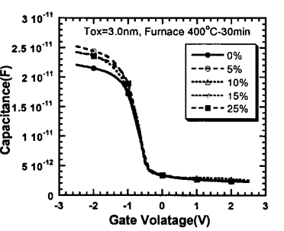

* Graph for N concentration of Dielectric material.

When the gate voltage is increased, the capacitance is decreased.

Gate voltage vs. Leakage current

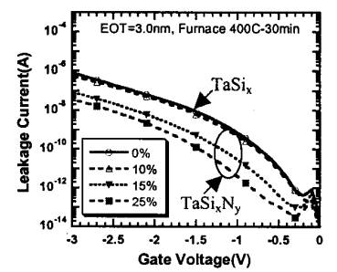

When the gate voltage is decreased, the leakage current is increased.